MIDDLE EAST TECHNICAL UNIVERSITY
ELECTRICAL AND ELECTRONICS ENGINEERING DEPARTMENT

EE 493 Conceptual Design Report


Project Name: War Zone Simulation
Company Name: S.P.Q.R.
To: Asst. Prof. Afşar Saranlı
Middle East Technical University
Ismet Inonu Bul. 06531 ANKARA
Tel: +90 312 210 45 29

Company Owners: Mr. Süleyman Adanır – Head of Research Department
+90 533 384 08 10
Mr. Emre Akgül – Hardware Engineer
+90 505 745 74 92
Ms. Betül Aydın – Project Coordinator
+90 537 723 02 29
Mr. Çağlar Aytekin – Software Engineer
+90 544 450 38 87
Mr. Burak Bostancı – Software Engineer
+90 505 745 74 92
Due: 17 December 2007
Project Starting Date: 1 December 2007
Project Duration: 6 months
Project Completion Date: 1 June 2008
Estimated Cost: 150 YTL

Table of Contents

Introduction and Background Information………………………………….…………3
Statement of the Problem and Goals………….………………………………………..5
Constraints and Scope of the Project…...……………………………………………...6
Design Requirements………...………………………………………………………...6
Alternative Solutions...…………………………………………………………………7
Organization and Evaluation Tools.…………………………………………………..11
Summary of Analysis and Test Procedures…………………………………………..13
Conceptual Description of Design………..…………………………………………..14
Gantt Chart……………………………………………………………………………16
Steps from Concept to Completion…………………………………………………...17
Foreseeable Difficulties and the Contingency Plan…………………………………..18
Cost Analysis……………………………...………………………………………….19
Conclusion……………………………………...…………………………………….20
References……………………………………...……………………………………..21
Appendices…………………………………...……………………………………….22

Introduction and Background Information
As technology progresses, military forces around the world are relying more and more on military simulations for emergency cases and risk assessment. Our project’s aim is to portray a realistic scenario in which an armed force engaged in multiple warzones will be able to receive, prioritize and respond to multiple emergency calls coming at the same time. Emergency calls are ‘help calls’ coming from the warzones, calling for reinforcements. Multiple reinforcement troops are also available, but there is a single troop carrying vehicle. The central command will optimize the best way to respond to help calls, and the vehicle will carry troops to different warzones one by one according to orders from the central command.

Problem Recognition
Challenge of this project is receiving a large number of help calls without interference; deciding the best way to respond according to a predetermined algorithm, and sending the vehicle to ferry troops. Locating the correct troop and warzone successfully is an important problem. Troop locations are not constant, and warzone identities must be interchangeable. Also, the vehicle should be fully automatic, smooth and fast; while is able to run on simple batteries for a long time.

Adaptation of the Project Scenario
For the sake of making our project more interesting and more open to extra features, we have rebuilt the original project definition and changed it into a ‘War Zone Simulation Project’. While making this change, we have taken the main criteria of the project into consideration, so that none of the desired functions of the system are ignored. These functions of the original scenario and the corresponding functions in our scenario are listed and matched one by one:

- In the original definition, there should be at least 3 needies which are relocatable.
- In our definition, we have at least 3 war zones which are relocatable.

- In the original definition, there should be at least 4 help centers. They should either be relocatable or their identities be interchangeable.
- We will have at least 4 different types of troops. They will either be relocatable or their identities be interchangeable.

- The original definition requires the vehicle to transport the needies to the most suitable help center. The suitability is determined by matching the identity of the help center to the need of the needy.
- Our vehicle will transport the most suitable troop to the war zone. The suitability is determined by matching the attributes of the troop to the specific need of the war in the war zone.

- In the original definition, ‘priority’ is another concept we should consider.
- Our system will first respond to the warzone which needs most urgent support.

Statement of the Problem and Goals
The system will be able to answer 3 different emergency calls from 4 or more different kinds of troops; then prioritize them. Then it will locate most important troop, and send the vehicle to pick it up. Then, the correct warzone will be located among 2 others. The vehicle will travel to the respective warzone and deliver the troop. Then; it will go to the second important troop and repeat the process until all troops are placed.

Our goals include:
- Providing communication protocols between troops, the emergency assessment center, the troop carrier emergency vehicle, and the warzones. No hardwires on the vehicle.
- Having a prioritization algorithm complex enough to enable the user many different warfare scenarios, without being impractical.
- To achieve flexible and easy mobility for the troop carrying vehicle.
- Being able to locate the correct troop or warzone reliably and being able to navigate the vehicle to its target without error.

Constraints and Scope of the Project
- 3 different warzones
- At least 4 troops
- No hardwires on the vehicle
- The whole system must not cost more than 150YTL
- Whole system must fit into an area of 1.5m-1.5m
- The project must be ready for demonstration by June 2008.

Design Requirements
- Vehicle will have no hardwires.
- More kinds of troops than there are warzones, so the prioritization algorithm will work at every step.
- Troop locations changeable
- Warzones must either be able to interchange identities or have their locations changeable
- As an extra feature, a sufficiently complex prioritization algorithm which takes decisions based on troop attributes (which can be set by the user).

Alternative Solutions
We have 3 alternative solutions differing in complexity, cost and reliability for this project.

Level 1 Solution)

Warzones:
All warzones will be passive, i.e. they will not communicate with transporting vehicle or troops for any purpose (navigation or identification). The properties and identities of warzones will be entered from a computer through an interface. The locations of the warzones will be determined by using a webcam and data will be fed back to transporting vehicle for navigation purposes.

Troops:
Troops’ locations are considered to be changeable but their properties can not be changed. Each troop will have LED’s on it to show their locations to transport vehicle. Once transport vehicle calls the specified troop, the troop understands this call and starts to emit light (visible or infrared light) so transport vehicle can find the locations of the troop by following the light. The vehicle will ‘call’ the troops based on either RF or Sonics. If sonics are used, each troop will respond to a particular ‘march’ or sound. RF version will simply send digital data, but is more expensive. After picking up the troop, following communication between vehicle and PC, vehicle will go to warzone.

Transport Vehicle:

Differential Drive System

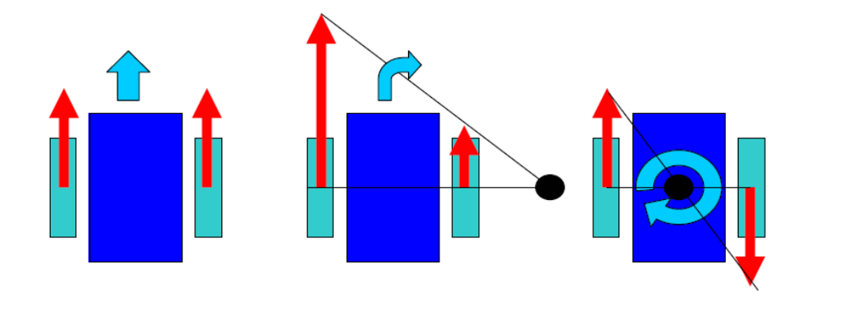
Figure 1

By the information taken from PC and from troops, transport vehicle first calls the needed troop (also through RF communication). By following the light that troop will emit, transport vehicle will pick the troop up. After that, by using image processing technique our vehicle will go to the desired warzone.

PC;

PC will process two types of data:
- Warzone’s need level for reinforcements
- Location of warzone

After processing, PC will decide which troop is going to which warzone. Then PC will send this information to transport vehicle through RF communication.

Level 2 Solution)

Once Level 1 is completed, for a more presentable solution; some more specifications can be added to troops. In Level 1; we only have four kinds of troops and their properties are not interchangeable. In this step changing the properties will be made possible and troop kind is risen to eight, instead of four. Note that there are again four troops in the battlefield, but they can be any four of the possible eight kinds. The basic improvement to level 1 is “choosing the most appropriate” troop for warzone. Property of the troop will be changed manually by changing the condition of switches on the troop.

Level 3 Solution)

If level 2 can be completed with success, we’ll move on with adding lots of abilities, specifications to troops and a much more complicated, yet realistic analysis will be made.
The troops will have these specifications;

- Strength: Determines the ability of the troop in close combat attack purposes.
- Dexterity: Determines the ability of the troop in ranged attack purposes.
- Vitality: Determines the ability of the troop in defense.
- Energy: The ability to stand harsh conditions and extremely exhausting battles.
- Line of Sight: Due to conditions of battlefield line of sight is an important issue. This specification determines how far the troop can see in the battlefield.
- Firepower: Exists only on siege machinery like ballistas, trebuchets, etc. Determines siege ability.
- War Experience: Determines how many wars did the troop attended before.

All of the specialties are having a number representing their strength on that ability over 16. Considering RF communications, with a computer, one can determine the abilities of the troops and the desired abilities by the warzones. Note that there is infinite number of troop kinds in this solution; the user may enter any specification about the troop. Note that since we need RF communications the cost of the project will increase in some amount which will be discussed in cost analysis. Note that warzones also will desire troops in terms of the specifications given above. After prioritization with the same procedure in level 1, the navigation process will be made.

Organization and Evaluation Tools
Our team organization chart is as Figure 2.
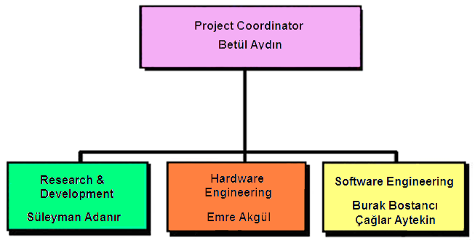
Figure 2
Our first major decision was choosing the project #5 (the help call project). The project was chosen by anonymous voting among the shareholders after strengths and disadvantages of each project option were evaluated through a voting system. Major factors in evaluation were Marketability of the Project, Benefits of the project to our engineering skills, the ease with which the project can be carried out and the fun factor of the project. After we felt that everyone has enough info on the projects, we proceeded with voting. Help call project won by a small margin.
Our second major decision was regarding the scenario of the project. We wanted a scenario that would stand out from the others without changing the basic requirements of the original project. After a brainstorming session, we decided on a Battlefield scenario. Instead of needies or patients, we would be ferrying troops. More info on the scenario and parallels between original scenario and ours can be found in problem statement and adaptation of the scenario parts of the report.
Our third major decision is forgoing mechanical solutions as much as possible. We want a large error margin and non-trivial solutions to the project. For example, our tiered laser solution for navigation was dropped due to its intolerance to error.
Our fourth major decision was forgoing webcam in favor of using light (visible or infrared) as a direction finding source. Our clientele did not favor a simple webcam solution and wanted us to limit the role of the webcam in the project. After many brainstorming sessions, we have decided that a RF intensive solution using light will be both practical and suitable to our budget.

Summary of Analysis and Test Procedures
-Our first test was on RF to test UDEA ARX-34/ATX-34 for range and power. We were satisfied with their qualities and performance and will use them in our project.
-Our next test was on sound detection. We were able to pick up sound and turn it to digital data. Different sound frequencies would produce different digital data. We are planning to use this system instead of RF to order the troops to light their LED’s which would cut down our resources and can be explained in the context of the scenario.
-We have obtained the motor and gearbox which will be used in the vehicle. We have tested the motor for required input current and performance and found out it drew 300mA. It is enough for our purposes and we will plan our battery purchases on this data.
Test procedures to be done:
-Our biggest concern is navigation system. To locate the troops, we will use light. A decision is not made yet whether to use visible or infrared light. Firstly, both of these will be tested for performance and reliability.
-Secondly, we will test the webcam to locate a simple object (for example a red ball). When we succeed in this task, we will further test the webcam to locate the warzones and direct the vehicle towards them.
-Sound detector system and the RF system will be tested together to observe if they work together. Then, RF, sound detector and navigation based on light will be tested together.
-We have tested infrared transmitter and receivers(TK19) and made them work. We are working towards sending data between them.
Conceptual Description of Design
Light Detection with LDR:
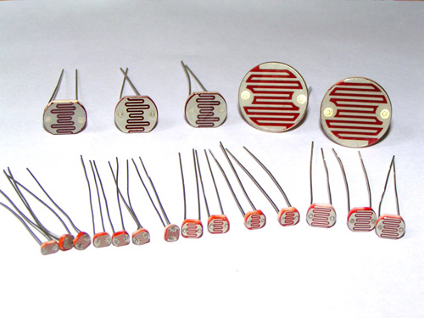
Picture 1: LDR
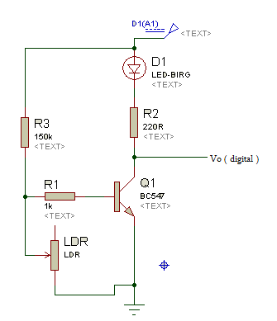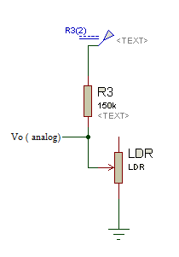
Figure 3: LDR digital output Figure 4: LDR analog output
We will use either digital output circuit or analog output circuit according to their efficiency.

TK-19 IR Detection:
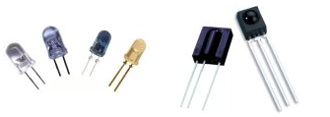
Picture 2: IR LEDs and receivers

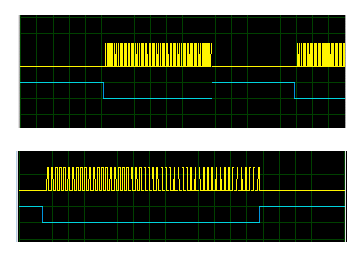
Figure 5: IR signal output of transmitter
TK-19 IR Detector detects 38 KHz signals. So by programming PIC, the IR LEDs should output that frequency of signal. When transmitters detects the signal, it outputs 0, otherwise outputs 1 (+5V) as in Figure 5 (the second one is the scaled version of the first).
Note: The description of UDEA ARX-34 Receiver and ATX-34 UHF Transmitter can be found in the appendices.

Gantt Chart
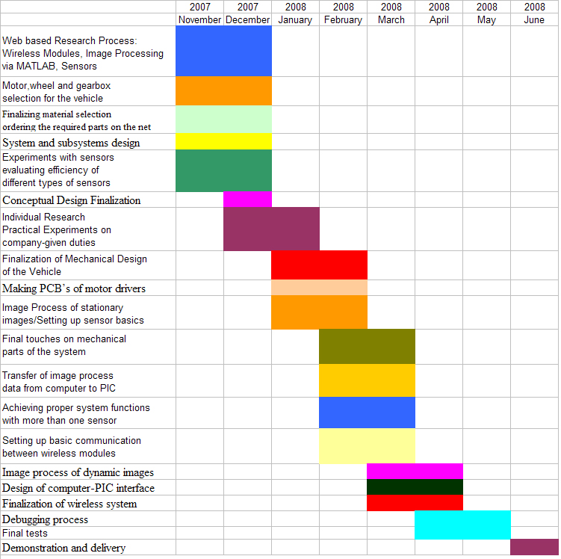
Figure 6: Gantt Chart

Steps from Concept to Completion
Test Period:
We will start with a variety of tests to finalize some design choices.
- For the navigation system, firstly the probable light source will be selected and some tests will be done on this. According to test results; we will change the source (e.g. IR) or improve its detection capability. If the light using solution is unsalvageable, we will use image processing as our navigation solution.
- We will test sound detection and decide whether to use it or RF.
- We will start on the user interface and image processing.
- We will prepare the PCB’s.
- We will purchase the 1.5x1.5 m. base platform.
- We will start on the mobility system of the vehicle.
Concept Realization Period:
- Mobility system of the vehicle will be finalized.
- We will prepare a single troop and the vehicle itself to prepare and test the navigation system.
- We will set up basic communication between nodes and the pc by RFcommunication.
- Design of computer-PIC interface.
- Design of software user interface.
- Finalization of image processing.
- Finalization of RF systems.
- Debugging process.
- Project demonstration.
Foreseeable Difficulties and the Contingency Plan
The difficulties we may face during test procedures may cause a little change in our project.
The main difficulty we may observe is unsatisfactory performance from light following navigation system. First step to overcome this difficulty is to improve our light detecting system, like using more detectable light or using higher number of sensors for a better detection. If these precautions do not suffice, we always have an alternative of using webcam for any navigation purpose, both for troops and the warzones. However this remains a last resort as we want to limit the use of webcam in our project.
Another difficulty we may face can be detection using sound. In such an occasion our alternative is to use RF communication.
To limit foreseeable difficulties we designed our solution in three steps with increasing complexity and difficulty. For example we will only spend effort on level 2 solution after level 1 is completely functional.
Contingency plan includes
- Using webcam
- Limiting the complexity of the prioritization algorithm.
- Using the minimum number of troops
- Using a less elaborate user interface.
Cost Analysis
Cost of Warzone: NULL

Cost of Vehicle:
Battery 6 YTL
RF Transmitter 7 YTL
RF Receviver 7 YTL
Motor and Gearbox 10 YTL
Sensors ( LDR or TK19 ) 10 YTL
PIC ; 8 YTL

Cost of Troop:
PIC 8 YTL
Battery; (4 X AA ) 2 YTL
Sensors (Ultrabright or IR LED) 10YTL
RF Receiver 7 YTL

Total Cost 48 + 27 x 4 = 156 YTL

Note: For Level 3, for each troop, the cost of RF transmitter will be added. That results: 4*7=28 YTL

Conclusion
In this report main body of the work done so far can be found. To sum up our work has been progressing on schedule. Since, majority of theoretical work is done; from this point on we will continue with some experimental tests. As we have mentioned our newly formed scenario is relevant to the original script. No doubt we will face some unforeseen difficulties, but we have some alternatives to overcome these problems.
We have some budget problem which can be solved by using the elements we will use more efficiently without changing the main solution. Our time table is relaxed enough, even to add extra features. We will prepare towards a demonstration in June 2008. Furthermore we really recognized that properly thinking and producing lots of theories for the solution of the problem is a much better and effective way than directly trying to solve the problem experimentally.

References
www.robot.metu.edu.tr
www.robotshop.ca
www.udea.com.tr

Appendices
ARX-34 UHF ASK Data Receiver
ATX-34 UHF ASK Data Transmitter

